# Problem Statement

HELP International is an international humanitarian NGO that is committed to fighting poverty and providing the people of backward countries with basic amenities and relief during the time of disasters and natural calamities. It runs a lot of operational projects from time to time along with advocacy drives to raise awareness as well as for funding purposes.

After the recent funding programmes, they have been able to raise around $ 10 million. Now the CEO of the NGO needs to decide how to use this money strategically and effectively. The significant issues that come while making this decision are mostly related to choosing the countries that are in the direst need of aid.

And this is where you come in as a data analyst. Your job is to categorise the countries using some socio-economic and health factors that determine the overall development of the country. Then you need to suggest the countries which the CEO needs to focus on the most.  The datasets containing those socio-economic factors and the corresponding data dictionary are also provided.

# Questions:

* Use any framework to define the problem statement.
* Use any of the approaches learnt during the session on problem solving and describe the above problem statement in detail.
* What kind of prioritization criteria would be at play here? Highlight potential trade-offs while solutioning & implementation

Problem statement

* What is the problem?
  + How to strategically and effectively use the fund of $10 million?
* Who/What does this problem impact?
  + The CEO of the NGO
  + The higher management of the NGO
  + The poor countries that will get helped
  + The governments of such countries
  + The people of such countries
* What happens if we do nothing?
  + The NGO might end up spending the money on the countries that are not in the direst need of it.
* What will success look like?
  + Finalizing the list of 3 to 5 countries that are in the direst need of the aid
  + Prioritizing these countries based on their needs
  + Finalizing the funds to be given for each of these countries based on their needs

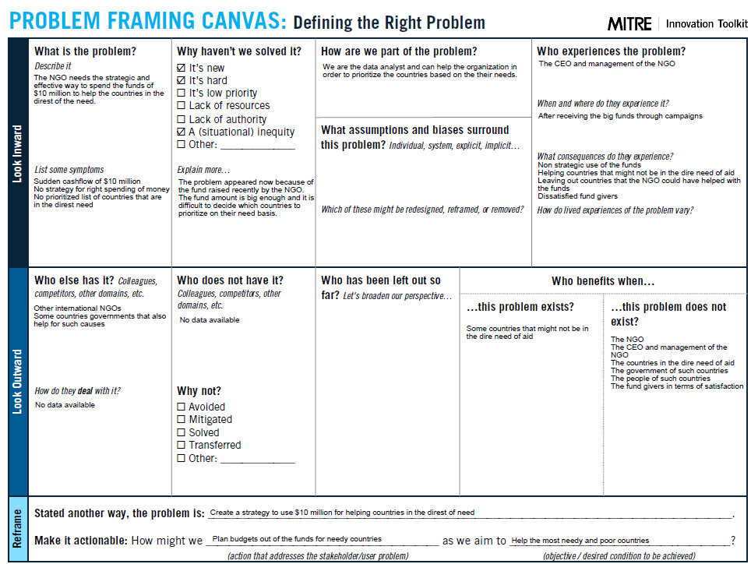

Now as we have framed the problem statement, there is some information / data missing here:

* What percentage of the funds are to be spent on helping the countries?
  + Is there any percentage of funds that we want to use for the NGO itself?
* How many critical countries do we need to help? Minimum and maximum numbers would help here.
* How will the funds be distributed to the needy countries? Are they to be given equally or the amount varies based on the need of the country?

For the provided data set, the following information is missing:

* The total population of the country
* The current funds available with the country / government
* Number of natural calamities and disasters in the past few years along with the following:
  + Number of deaths
  + Number of lives affected
  + Financial / property losses
  + Severity of those disasters / calamities
* Are there any black listed countries?
* Funds given to the countries in the past few years, by this NGO.

Solution:

Steps to follow based on the given data:

* Define the prioritization criteria for the countries
* Draw the priority based on each individual parameter
* Eventually, define the priority of the countries, combining all the individual priorities.

Note: We will use Bulls Eye diagram to define the priority, and we will limit it to the secondary level only, considering the budget available.

**Step #1: Defining priority criteria**

The following diagram defines the criteria to decide the prosperity vs adversity for a given country. Please note that some of the data is missing here which is indicated in the pink color.

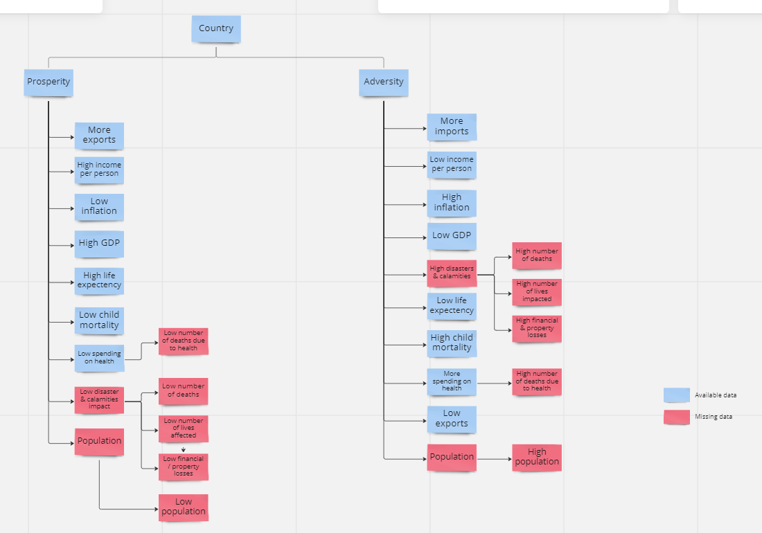

**Step #2: Prioritizing countries based on individual parameters:**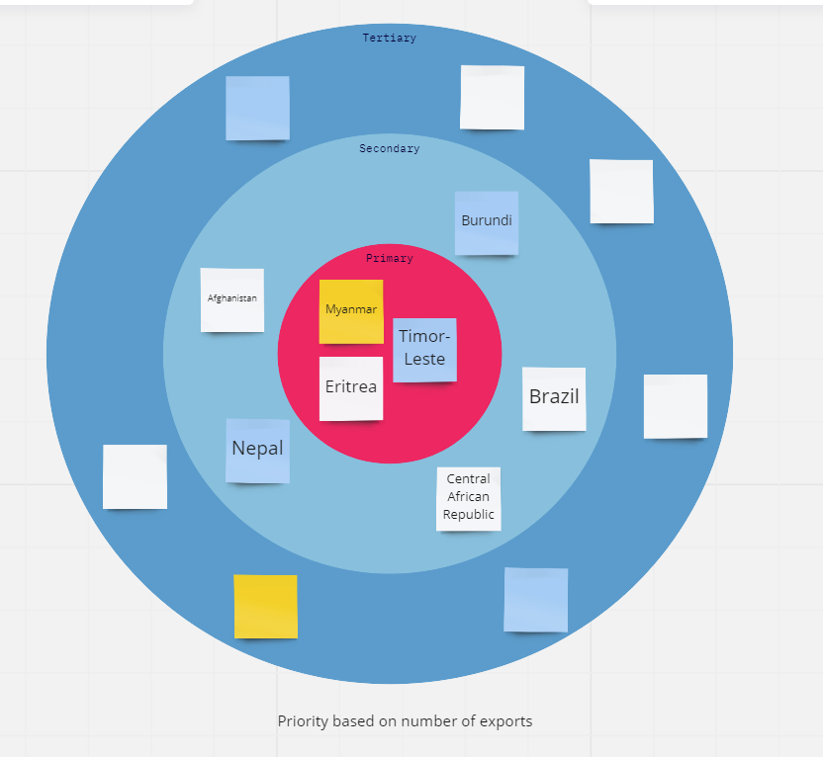

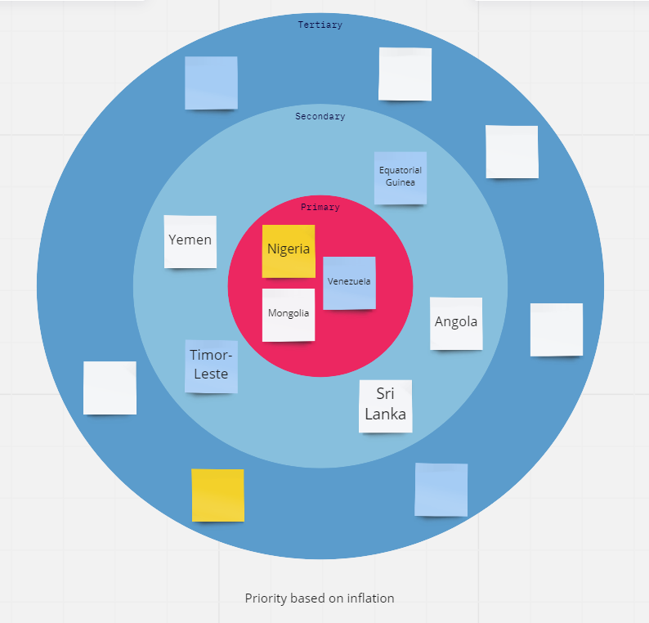

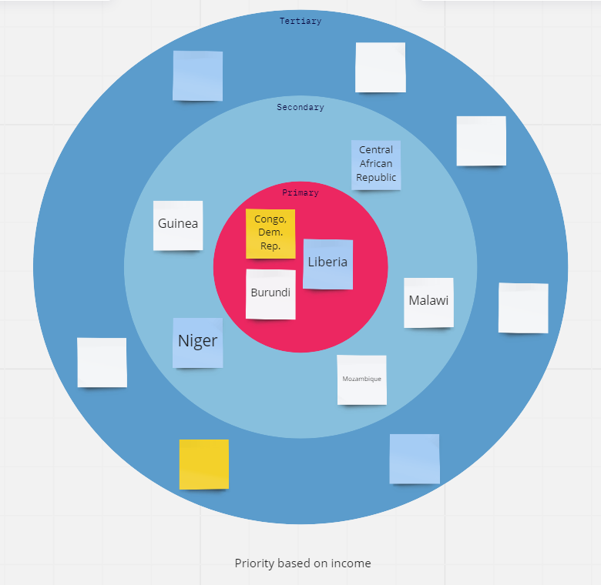

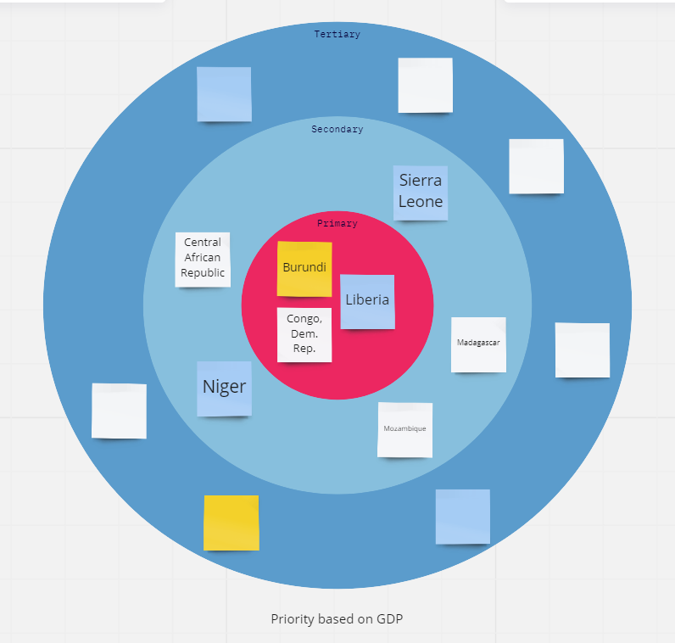

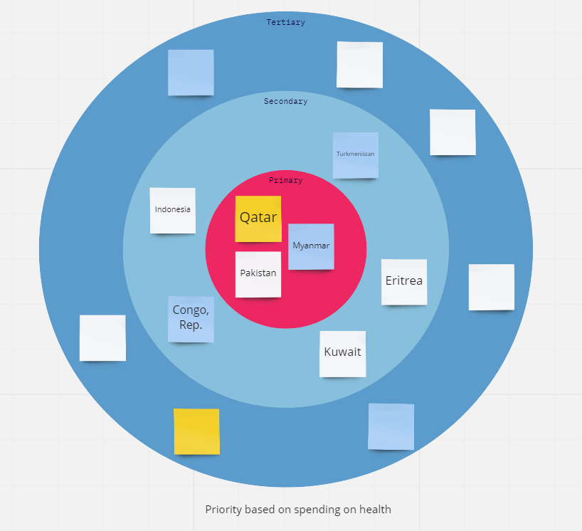

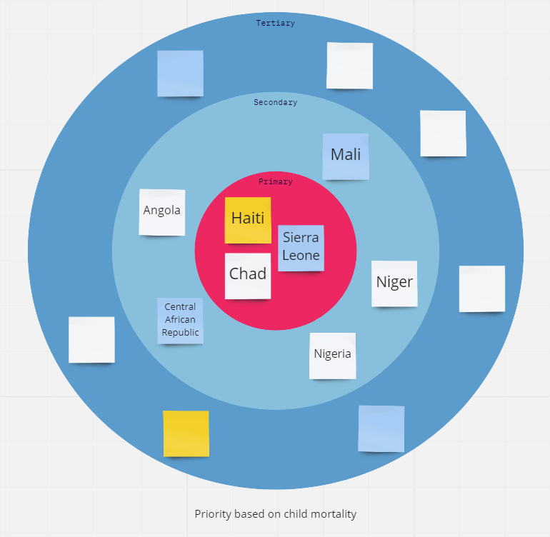

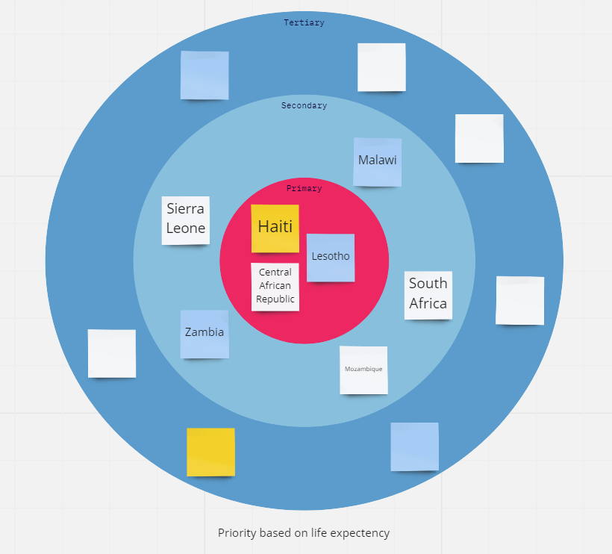

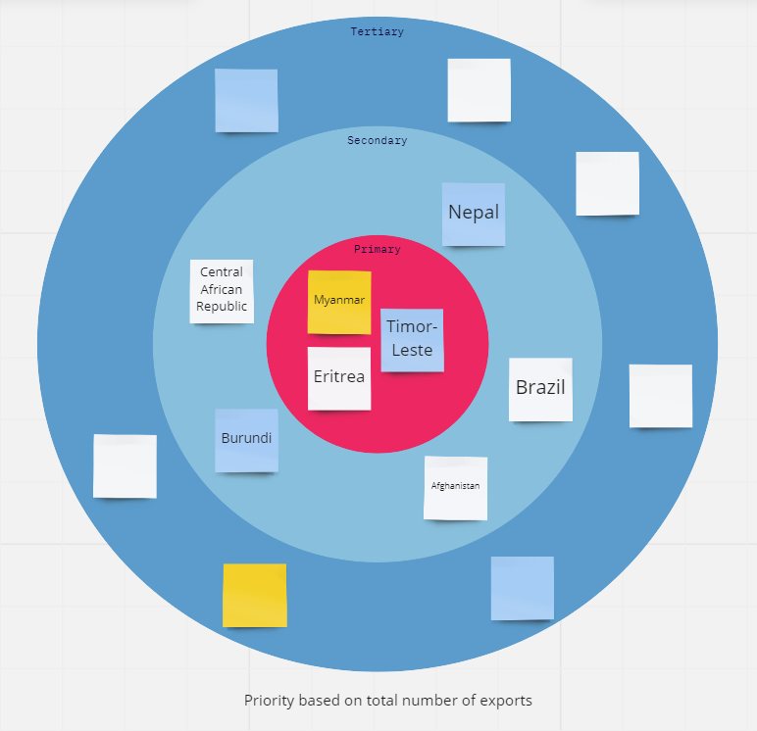

**Step #3: Final priority calculation**

